- We have multiple end-points. So need to make different response and request DTOs.
  - Previously we were using same DTO for request and response. But now we’ll not.
  - 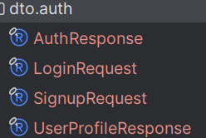
    - AuthResponse = UserProfileResponse+token.
    - LoginRequest and SignupRequest are DTOs for POST request payload.
    - You should create different DTOs for request and response.
    - For getProfile controller, only UserProfileResponse is needed, there is no need of token.
- We’ll use MapStruct for mapping of one class type to another instead of ModalMapper.
  - As we are using lombok as well, so we need to make sure that lombok will be executed first then MapStruct .
  - Because, both will be executed during compile time.
  - Annotation processors do NOT run sequentially like “Lombok first, MapStruct second”. They run in the same compilation round.
  - For this lombok-mapstruct-binding is required.
  - 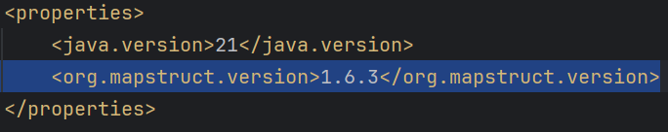 (variable)
  - 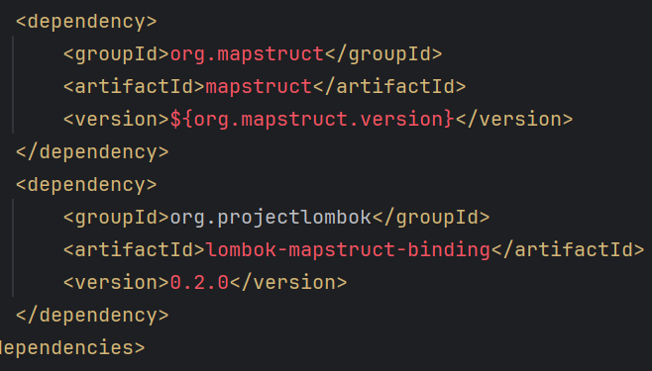
- Dependency vs Plugins
  - Dependencies are used by your application at compile/runtime.
  - Plugins are used by Maven to build your application.
- To create mapper (MapStruct),
  - 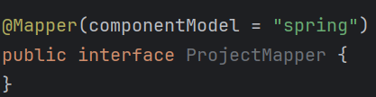
  - Use the componentModel=”spring”

